Name: Darek Konopka CS 102 - Quiz 3

There are 8 questions. Submit your answers on blackboard. (35 points)

- (2 points) Which of the following is NOT a property of a complete binary tree of height h?
  - all nodes at level h – 2 and above have two children each

  - when a node at level h – 1 has children, all nodes to its left at the same level have two children each
  - when a node at level h – 1 has one child, it is a left child
  - all leaves are at level h

- (2 points) A node on the path from the root to node n is a (n) ______ of node n.
    - ancestor
    - descendant
    - subtree
    - leaf

- (2 points) In ______, the left and right subtrees of any node have heights that differ by at most 1.
    - all trees
    - all binary tress
    - n-ary trees
    - balanced binary trees

- (2 points) A data element within a record is called a ______.
    - field
    - tree
    - collection
    - key

- (1 point) All binary search trees are balance.
  - True
  - False

- (1 point) Inorder traversal visits a node before it traverses either of its subtrees.
  - True
  - False

- (15 points) Consider a binary search tree of integers, orders traditionally (smaller values to the left, larger values to the right)

  - Draw the final binary search tree that results from adding the following items to an empty tree, in the order shown below:
1, 7, 2, 5, 8, 3, 6
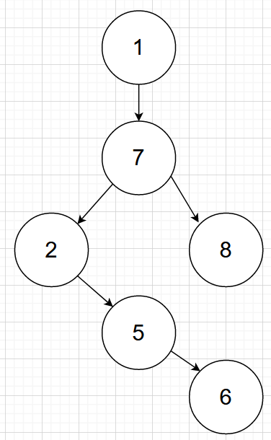

  - Consider the binary search tree above, list the tree nodes as visited in the: preorder traversal and postorder traversal.

Preorder:
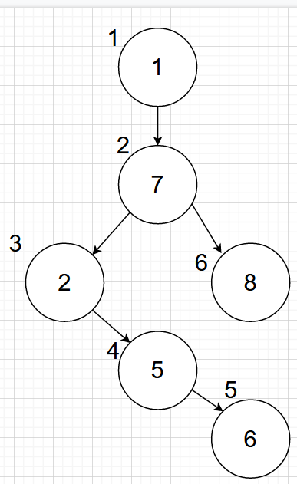

Postorder:
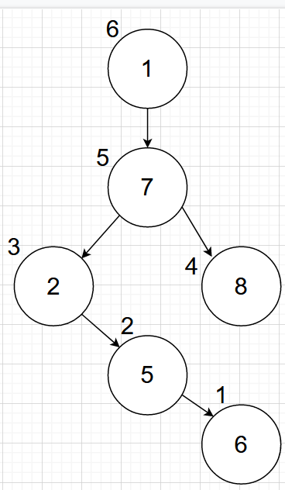

  - Draw the binary search tree that results from removing the value ‘2’ from the tree you drew above.
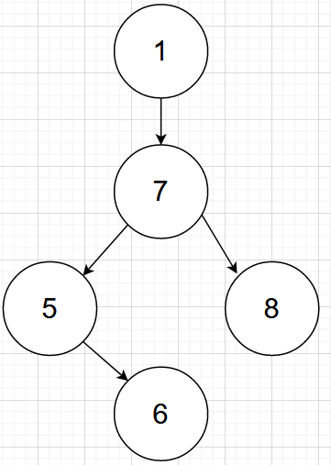

8. (10 points) Consider the flowing definitions for a binary tee:
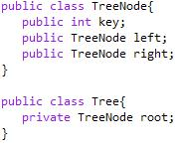

Implement (recursively) the method numOfNodesRec for the class Tree to compute the number of nodes at a specific level (e.g. the root node is at level 1, its children at level 2etc.) in a binary tree.
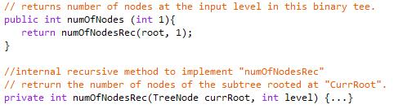

Public class TreeNode {
public object item;
public TreeNode leftChild;
public TreeNode rightChild;
int count() {
Tree rightChild = get rightChild();
Tree leftChild = get leftChild();
int counter = 1;
if (rightChild!=null) counter+= rightChild count();
if(left!=null) counter+= leftChild count();
return counter;
}
}

